Operating System Week-1

Name : Tanishq Vyas
SRN : PES1201800125
Section : H
Semester : 5
Branch : CSE

Ans. 1

1) Directory Listing

Command : ls
This command is used to list all the files and folders present within a directory.

Option : -l
This argument is used in order to long list the files and folders to show more informatiomn like permissions, user, size, date of creation/modification etc

Option : -a
This option is used to list all the files present by not ignoring the entries beginning with .

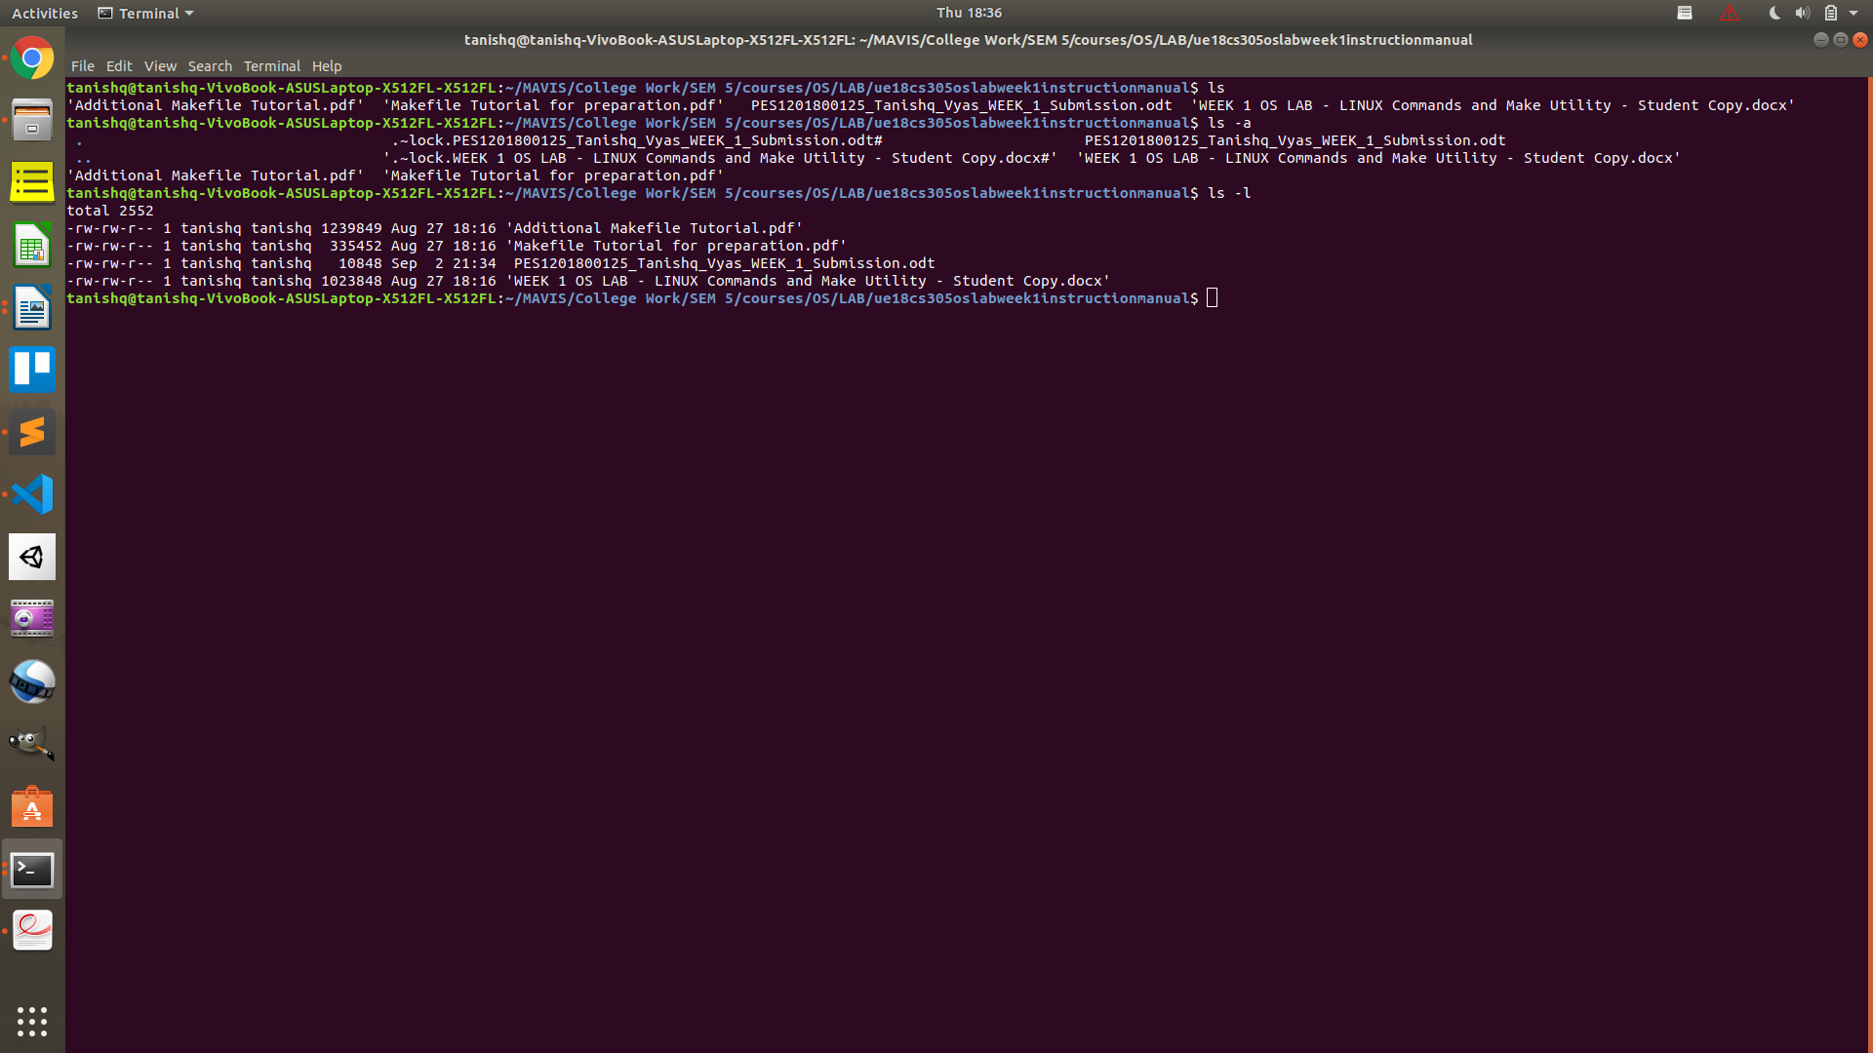

2) Display information about a selection of the active processes.

Command : ps

Option : -d
This is used to select all processes except session leaders.

Option : r
This restricts the selection to only running processes.

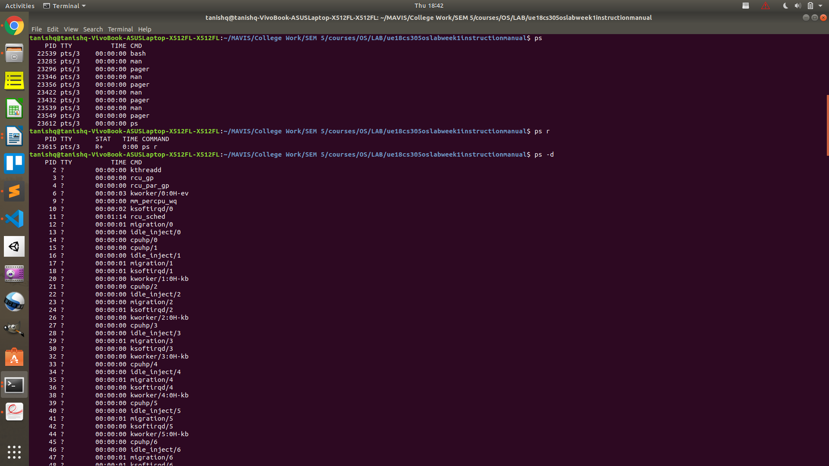

3) Remove files or directories

Command : rm
This command is used in order to delete the files or directories.

Option : -r
This helps remove directories and their contents recursively

Option : --force
This removes the files without any prompting. Force delete without prompting.

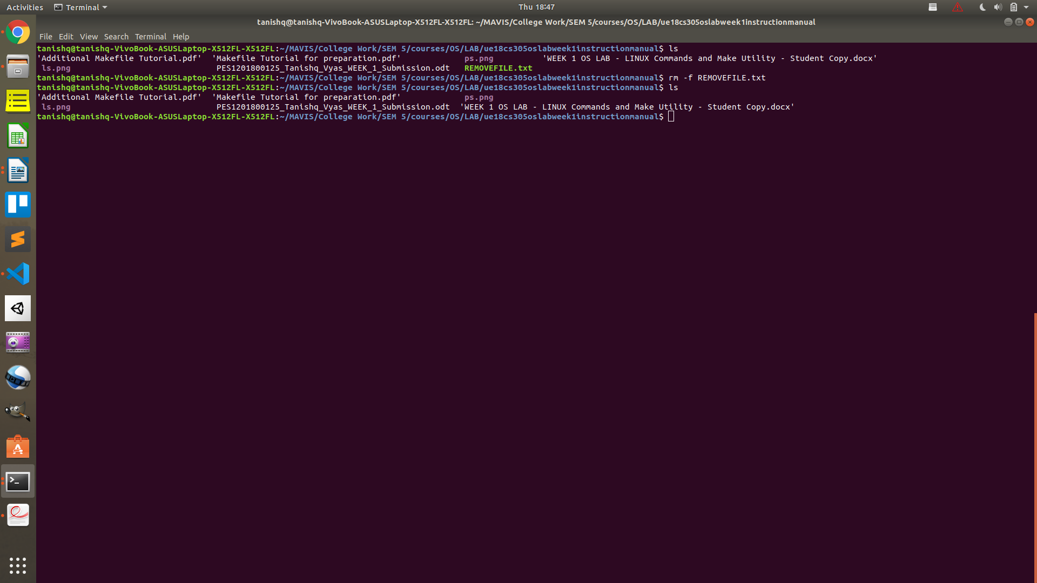

4) GNU make utility to maintain groups of programs

Command : make
The make utility will determine automatically which pieces of a large program need to be recompiled, and issue the commands to recompile them.

Option : -f
Used to specify to use a file as makefile

Option : -s
This argument specifies to make use of silent operation.

5) Copy files and directories

Command : cp
Used to copy files and directories from the source to the destination.

Option : -r
Used to copy the directories recursively

Option : -v
Explain what is being done. Basically set verbose = True.

Ans 2.

In order to execute the program type

1) make -f makefile.mk

This command creates the required executable .out file

2) ./a.out

This completes the execution of the program successfully in Linux environment.

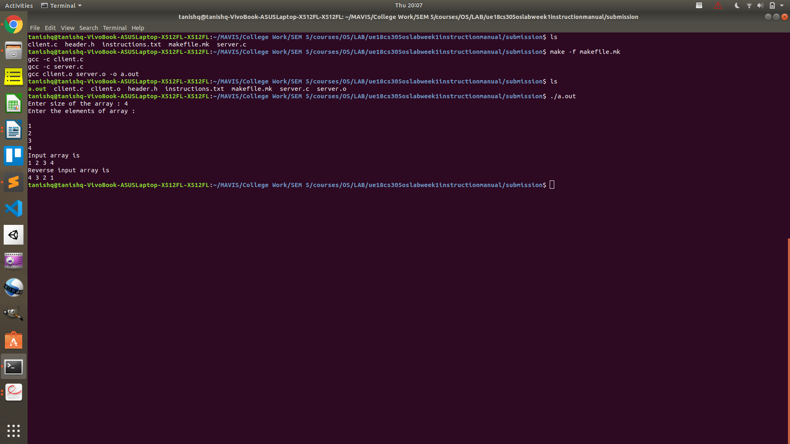

Ans 3.

1) We use makefiles in order to make the compiling of our programs easier by saving us the trouble of typing the names of all source files and dependancies. The makefile works on the principle that files only need recreation if their dependencies are changed/recreated. It contains a set of shell commands which helps automate the overall compiling of the program.

2) No, makefile i not a shell script.

3) Clean helps us to get rid of our object and executable files. Thus helps us with a fresh start in case of wrong linking.

4) It simply looks at the timestamp corresponding to each file’s and its dependencies last modification/creation. Thus it get’s to know whether the files were modified after the last make command execution.

5) This is either the name of environment variables or of makefile variables that can be set to specify additional switches to be passed to a compiler in the process of building computer software.

6) The -f option is used to specify that use the filename that follows as the makefile for execution.

